EXPERIMENT 4

ROLL NUMBER:240701307 NAME: MAUNEESHWARAN.N

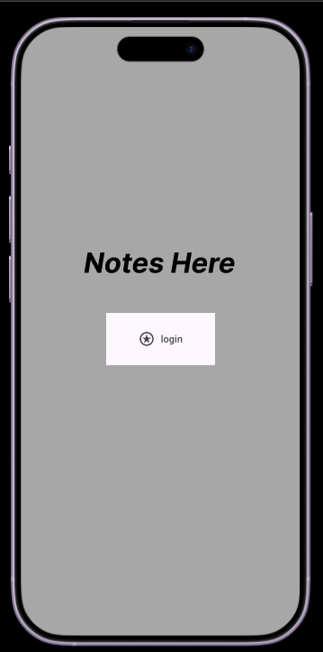
1. Home / Welcome Screen — “Notes Here”
Purpose:
This is the landing page of the app.
Main Elements
- App title: Notes Here
- Single Login button
- Clean minimal design
Functionality
- First screen users see after opening the app.
- User taps Login to continue.
- Acts as an entry point before authentication.

2. Login Screen — Sign In
Purpose:
Allows users to securely access their account.
Main Components
- User icon with security theme
- Username / Email field
- Password field
- LOG IN button
- Options:
  - Forgot Password
  - Create Account
Functionality
- User enters credentials.
- System validates login details.
- If authentication succeeds → next screen opens.
Navigation:
Login Screen → Subject & Year Selection

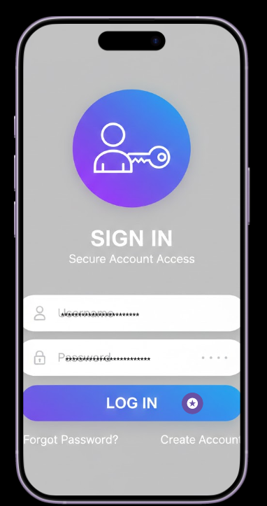

3. Subject & Year Selection Screen
Purpose:
Helps users choose which notes they want.
Main Options
- Subject Selection
  - Choose course or subject (e.g., Physics, Maths, Programming)
- Year Selection
  - Select academic year (e.g., 2024)
Functionality
- Filters notes based on:
  - Subject
  - Academic year
- Prepares download request.
Navigation:
Select Subject + Year → Download Process

3. Subject & Year Selection Screen
Purpose:
Helps users choose which notes they want.
Main Options
- Subject Selection
  - Choose course or subject (e.g., Physics, Maths, Programming)
- Year Selection
  - Select academic year (e.g., 2024)
Functionality
- Filters notes based on:
  - Subject
  - Academic year
- Prepares download request.
Navigation:
Select Subject + Year → Download Process

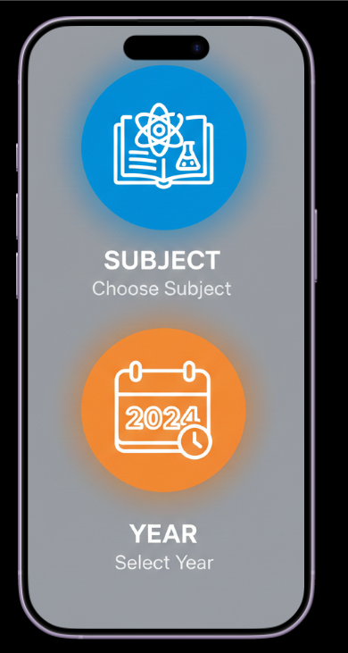

Application Concept
This app is designed as a:
Student Notes Management System
Academic Material Downloader
Offline Study Resource App
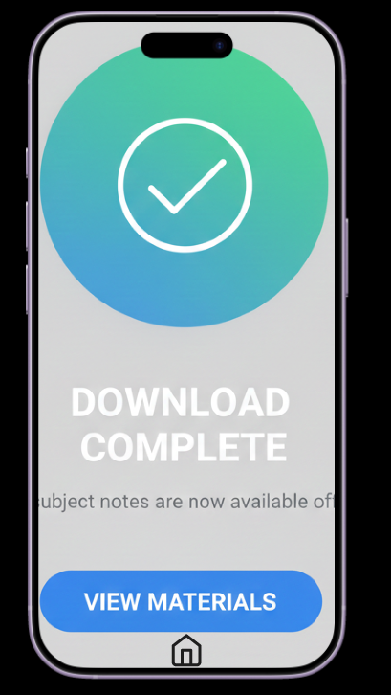

Overall App Flow
Home Screen
↓
Login Screen
↓
Select Subject & Year
↓
Download Notes
↓
Download Complete
↓
View Materials

PROTOTYPE LINK:

https://www.figma.com/proto/hAPPPpfKO8xQndjX9UA4mm/Untitled?node-id=1-3&starting-point-node-id=1%3A3&t=tHTwWJTfGSoK44wi-1

